JDK SETUP

Double click on jdk-17.0.12_windows-x64_bin.exe to install.

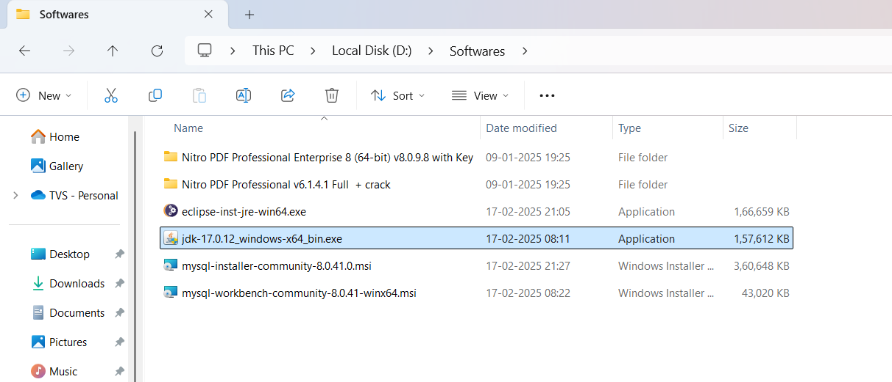

Click windows button then type environment variables

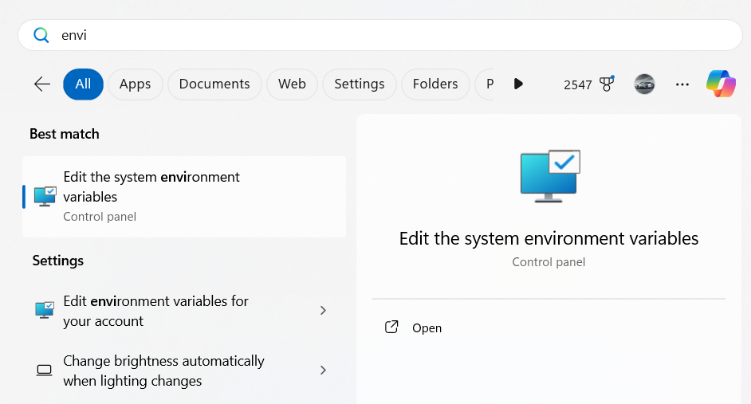

Click on Environment Variables

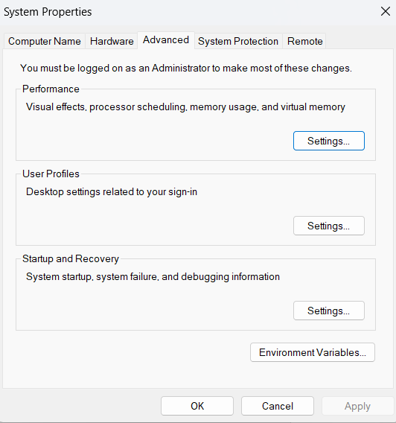

Double click on Path

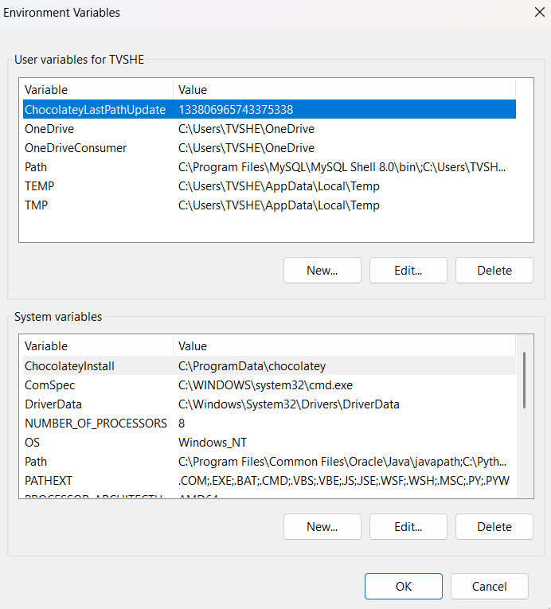

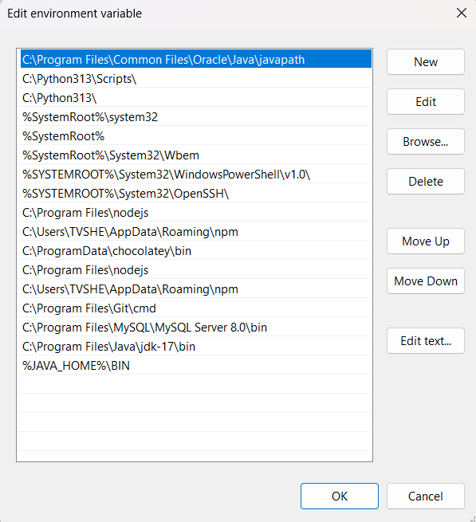

3

2

1

1. Click on new
2. Type %JAVA_HOME%\BIN
3. Click on ok

Go to This location => C:\Program Files\Java\jdk-17 **OR JDK** app installed location then click on path and copy path

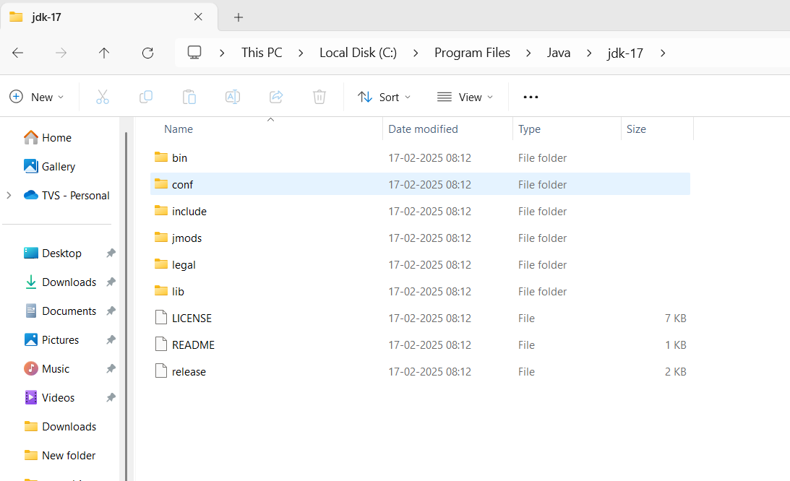

Click on new

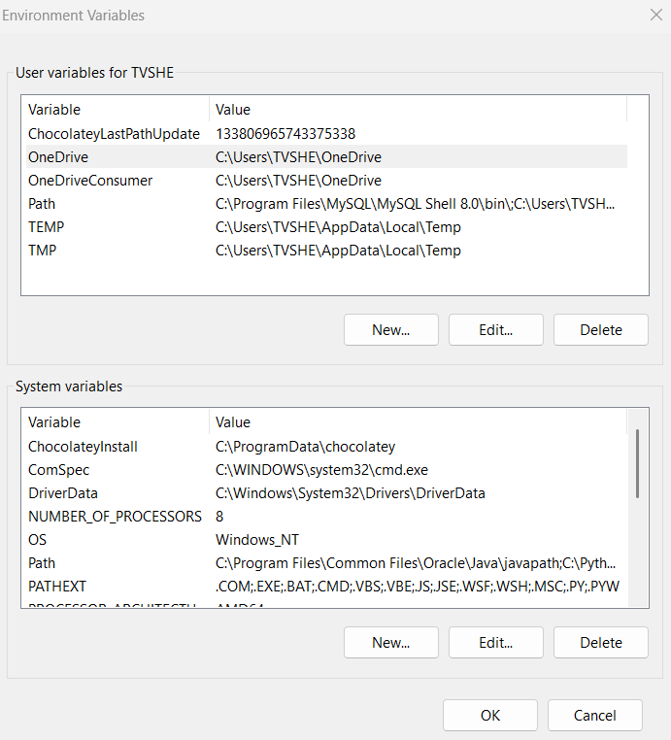

Then enter

Variable name: JAVA_HOME

Variable Value: paste the copied path

Then click on OK

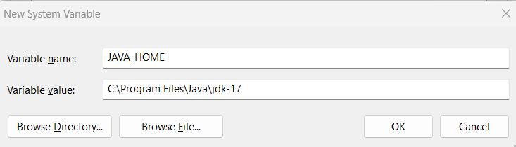

TO CHECK JDK installed properly or not

Open cmd

To check java version type -> java –version

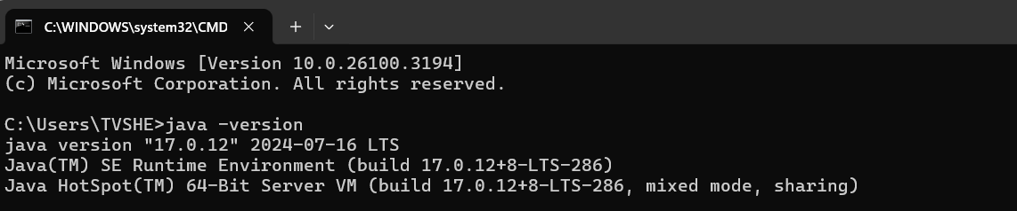

To check java compiler version => javac –version

Java & javac version should be same

